
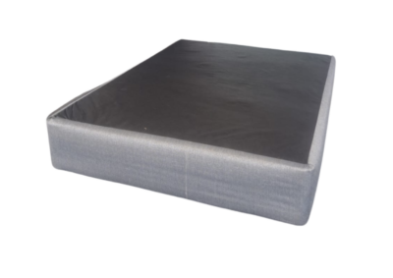

Model : Universal Heavy Duty Base
Manufacturer : Mattress World
Features :
- Heavy Duty 7 Slat Design
- 6 Legs for Extra Support
- Luxury Textile Fabric
- 120kg Per Person Per Side
Prices Standard Length :
- Single – R999
- Three Quarter – R1099
- Double – R1499
- Queen – R1599
- King (2 x Singles) – R1998
Prices Extra Length :
- Single – R1199
- Three Quarter – R1319
- Double – R1799
- Queen – R1919
- King (2 x Singles) – R2399

